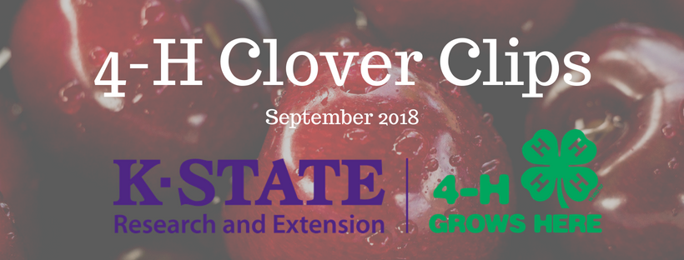
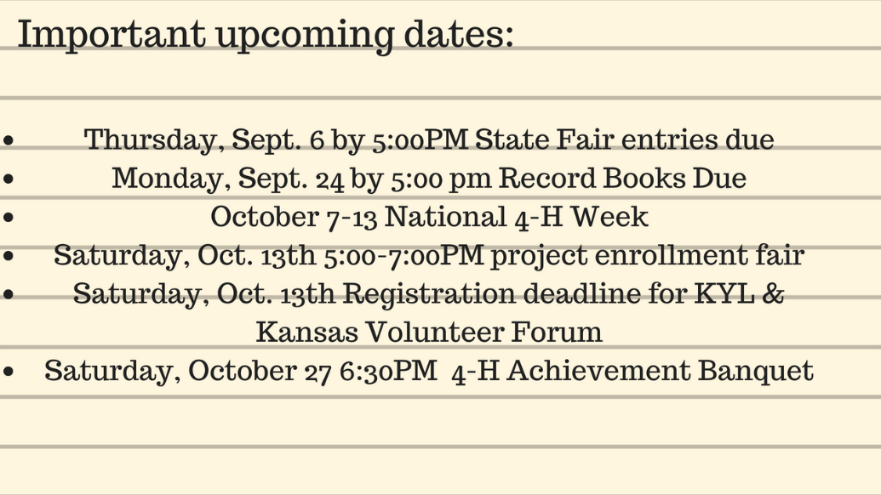
ACHIEVEMENT BANQUET
4-H Achievement Banquet Saturday, October 27
6:30 p.m.
Lawson Room, Civic Center.
RSVP By October 16th

Record Books DUE!!!!
Record Books are due to the Extension Office on September 24, 2018. The books will be judged and County Champions will be determined for each project. Awards will be presented at the Achievement Banquet. Achievement Pin Plans and County Champion designation forms are due with your Record Books and are available at the Extension Office. Key Award applications are also due at this time. Check with the Extension Office to see if you are eligible.

If you do not turn in a Record Book you will not receive any awards including the membership year pins.

State Fair Entries
If you are entering in the State Fair they need to be to the Extension Office by 5:00 p.m. on Thursday, September 6th.

Project Enrollment Fair
October 13, 2018
Lawson Room
5:00 PM-7:00 PM
You will also need to re-enroll on
4-H On-Line beginning
October 1st.

Please make sure all your information is updated.
NATIONAL 4-H WEEK
October 7-13, 2018
Please do whatever you can to promote 4-H during “National
4-H Week.” Let Grant County know all about 4-H!

PROJECT LEADERS
If you are interested in being a project leader or if you were one last year, please call the Extension Office and let us know what project you would be interested in being a leader in or which one you would like to continue to be one in. Let us know as soon as possible.

AMBASSADORS
Be thinking about being a Grant County 4-H Ambassador. Applications will be DUE on November 1st. Come by the Extension Office and pick up an application. For 9th -12th Grade Students. If you have any questions call the Extension Office.
Officer Training:
We will let you know when we have a date set.

Promote 4-H
We will be promoting 4-H at Fall Fest on Saturday, October 7th. The hours are 10:00 a.m. to
3:00 p.m. or until we run out of handouts. This is a 4-H Event so any help would be greatly appreciated. Ambassadors are asked to help also.
We will be giving out Promotional
Handouts to those interested in joining 4-H

Kansas Youth Leadership Forum
&
Kansas Volunteer Forum
November 17-18, 2018 at Rock Springs 4-H Center
Registration Deadline is
October 13th.

Once again, Kansas 4-H is promoting a weekend of community service for 4-H’ers to give back to their communities. We want to encourage clubs and individuals to plan their own 48 hours activities this year.

48 Hours of 4-H will be October 7-8, 2017, in every extension unit across Kansas. You can go to the Kansas 4-H website for more information and ideas.

