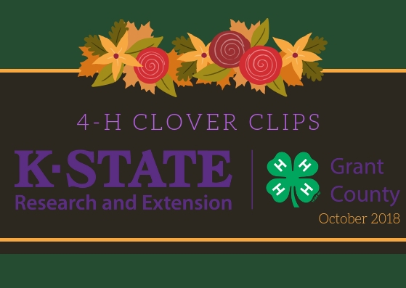

It is time to kick-off a NEW 4-H year. Starting with the Fall Fest where we will be handing out information on joining 4-H. Also reminder that 4-H Week is October 7-13, 2018. Let’s all go out and promote 4-H. Don’t forget about Project Enrollment Fair: Saturday, October 13th. Come and bring a friend. Enrollment starts October 1st.

Kansas Youth Leadership Forum
and Kansas Volunteer Forum
November 17-18, 2018
REGISTRATION DEADLINE IS
OCTOBER 15th
Youth & Adults - $165.00 on or before October 15th. Starting October 16th the fee will be $190.00 for youth & adults. For ages 14-18 years old by January 1, 2019.

Achievement Banquet
Saturday, October 27, 2018
6:30 p.m. – Lawson Room
RSVP by October 15th.

Everyone is welcome to our
End of the 4-H Year
Celebration!!!

There will be:
Record Book Awards
Community Club and
Project Leader
Awards
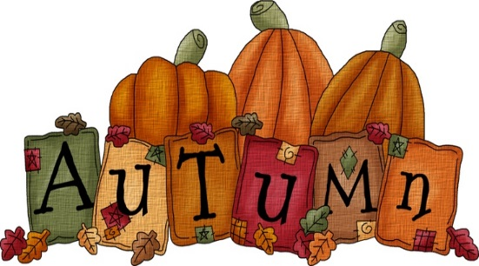
Fair Herdsman Award
Friend of 4-H

Catered Meal
Come and enjoy a great evening
of fun and excitement
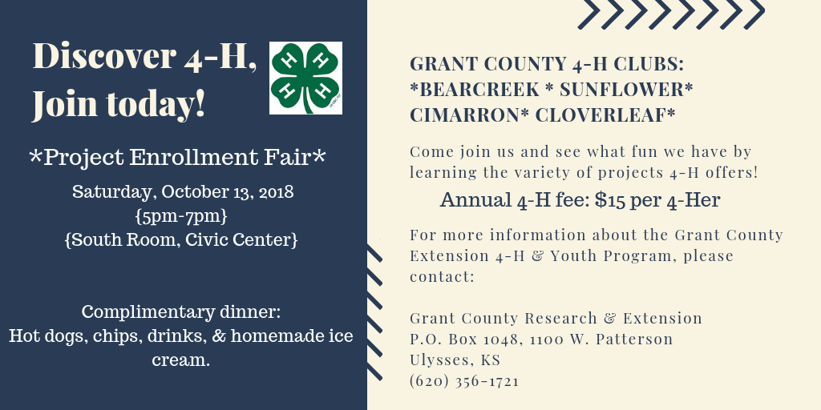

Project Leaders
If you are interested in being a project leader or if you were one last year, please call the Extension Office and let us know what project you would be interested in being a leader in or which one you would like to continue to be one in. We still have some openings if anyone is interested. Let us know as soon as possible.

Attention!!!!
Think about being a 4-H Ambassador. Applications are due November 1st. Come by the Extension Office and pick up an application. For 4-H’ers 9th – 12th grade. Call the Extension Office if you have questions.
